**Lab Report. 01**

# *Lab Experiment:* Scan Conversion of point,line(using DDA and Bressenham algorithm) and circle(using Bressenham algorithm)

*Course Title: Computer Graphics Laboratory*

*Course code: CSE-304*

*3rd Year 1st Semester Examination 2022*

**Date of Submission**: 28/05/2023



###### **Submitted to-**

##### Dr. Mohammad Shorif Uddin

Professor

Dr. Morium Akter

Associate Professor

###### 

###### *Department of Computer Science and Engineering*

*Jahangirnagar University*

*Savar, Dhaka-1342*

|  |  |  |  |
| --- | --- | --- | --- |
| **Sl** | Class Roll | Exam Roll | Name |
| 01 | 347 |  | Sadia Hossain |

**1.Experiment Name: Scan Conversion of Point**

**Code:**

**#include<iostream>**  
**#include<graphics.h>**  
**#include<dos.h>**  
**#include<conio.h>**  
**using namespace std;**  
**int main()**  
**{**  
**int x0,y0,x1,y1,i,x,y;**  
**cout<<"Enter first coordinate"<<endl;**  
**cin>>x0>>y0;**  
**int gr=DETECT,gm;**  
**initgraph(&gr,&gm,"C:\\TURBOC3\\BGI");**  
**putpixel(x0,y0,RED);**  
**getch();**  
**closegraph();**  
**return 0;**

**}**

**Output:**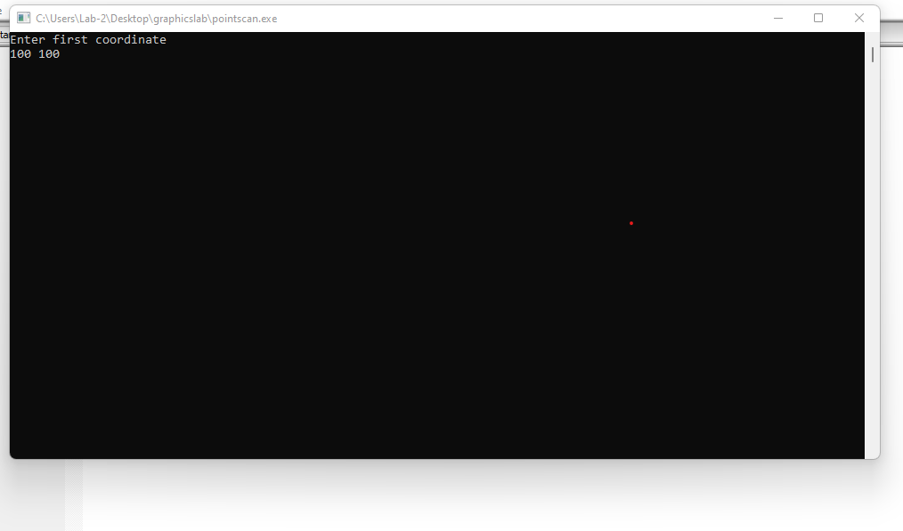

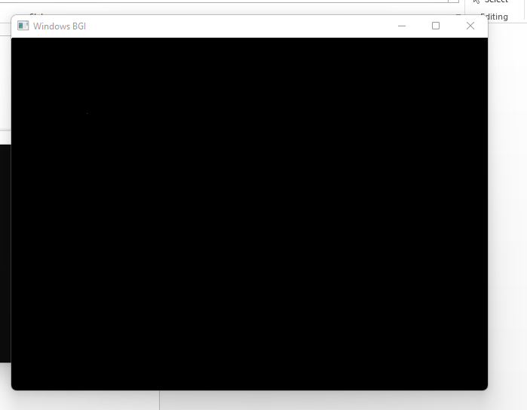

**2.Experiment Name: Scan Conversion of a line using DDA algorithm**

**Code:**

**#include<iostream>**  
**#include<graphics.h>**  
**#include<dos.h>**  
**#include<conio.h>**  
**using namespace std;**  
**int main()**  
**{**  
**int x0,y0,x1,y1,i,x,y;**  
**cout<<"Enter first coordinate"<<endl;**  
**cin>>x0>>y0;**  
**cout<<"Enter the second coordinate"<<endl;**  
**cin>>x1>>y1;**  
**int dx=(x1-x0);**  
**int dy=(y1-y0);**  
**int steps;**  
**int gr=DETECT,gm;**  
**initgraph(&gr,&gm,"C:\\TURBOC3\\BGI");**  
**if(dx>=dy)**  
**{**  
 **steps=dx;**  
**}**  
**else**  
**{**  
**steps=dy;**  
**}**  
**dx=dx/steps;**  
**dy=dy/steps;**  
**x=x0;**  
**y=y0;**  
**for(i=1;i<=steps;i++)**  
**{**  
 **putpixel(x,y,RED);**  
 **x+=dx;**  
 **y+=dy;**  
**}**  
 **getch();**  
 **closegraph();**  
**return 0;}**  
**Output:**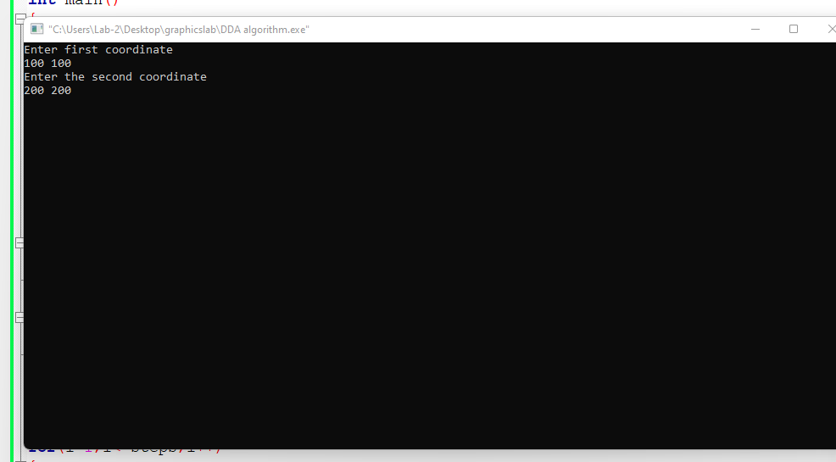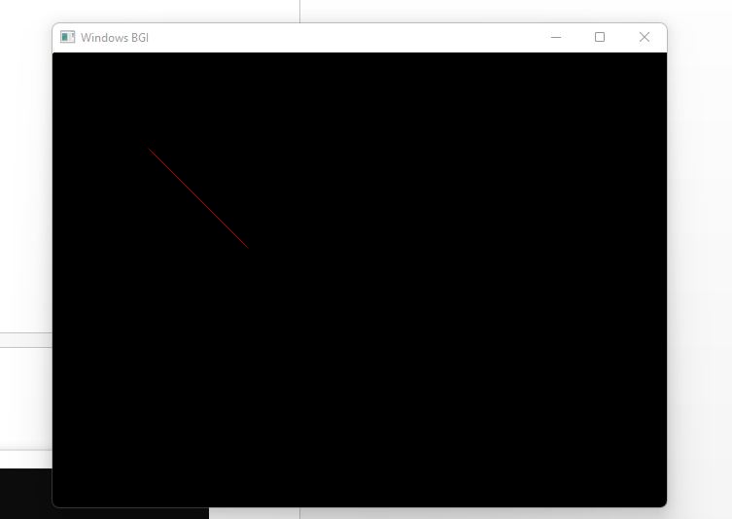

**3.Experiment Name: Scan Conversion of Line using Bressenham algorithm**

**Code:**

**#include<iostream>**  
**#include<graphics.h>**  
**#include<conio.h>**  
**#include<dos.h>**  
**using namespace std;**  
**void drawline(int x0, int y0, int x1, int y1)**  
**{**  
 **int dx, dy, p, x, y,d,dS,dT;**  
 **dx=x1-x0;**  
 **dy=y1-y0;**  
 **x=x0;**  
 **y=y0;**  
 **dS=2*dy;**  
 **dT=2*dy-2*dx;**  
 **p=2*dy-dx;**  
 **while(x<x1)**  
 **{**  
 **if(p>=0)**  
 **{**  
 **putpixel(x,y,RED);**  
 **y++;**  
 **p+=dT;**  
 **}**  
 **else**  
 **{**  
 **putpixel(x,y,RED);**  
 **p+=dS;**  
 **}**  
 **x++;**  
 **}**  
**}**  
**int main()**  
**{**  
**int x0,y0,x1,y1,i,x,y;**  
**cout<<"Enter first coordinate"<<endl;**  
**cin>>x0>>y0;**  
**cout<<"Enter the second coordinate"<<endl;**  
**cin>>x1>>y1;**  
**int gr=DETECT,gm;**  
**initgraph(&gr,&gm,"C:\\TURBOC3\\BGI");**  
**drawline(x0,y0,x1,y1);**  
**getch();**  
**closegraph();**  
**return 0;**

**}**

**Output:**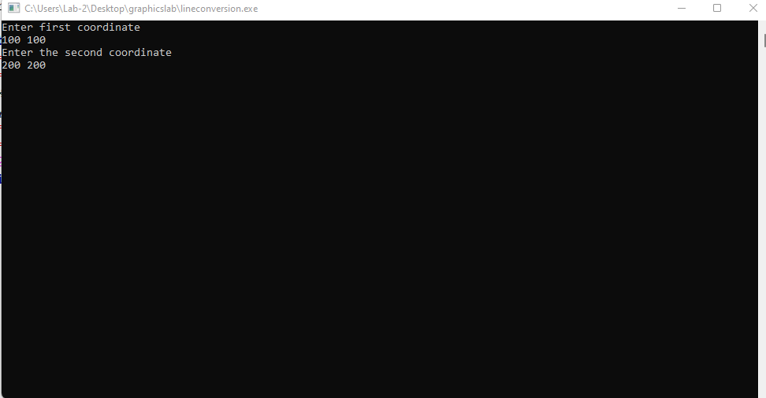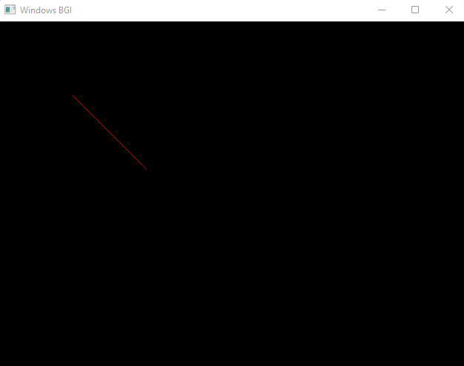

**4.Experiment Name: Scan Conversion of Circle using Bressenham algorithm**

**Code:**

**#include <iostream>**  
**#include <dos.h>**  
**#include <graphics.h>**  
**using namespace std;**  
**void drawCircle(int xc, int yc, int x, int y)**  
**{**  
 **putpixel(xc+x, yc+y, RED);**  
 **putpixel(xc-x, yc+y, RED);**  
 **putpixel(xc+x, yc-y, RED);**  
 **putpixel(xc-x, yc-y, RED);**  
 **putpixel(xc+y, yc+x, RED);**  
 **putpixel(xc-y, yc+x, RED);**  
 **putpixel(xc+y, yc-x, RED);**  
 **putpixel(xc-y, yc-x, RED);**  
**}**  
**void circlebres(int xc, int yc, int r)**  
**{**  
 **int x = 0, y = r;**  
 **int d = 3 - 2 * r;**  
 **drawCircle(xc, yc, x, y);**  
 **while (y >= x)**  
 **{**  
 **x++;**  
  
 **if (d > 0)**  
 **{**  
 **y--;**  
 **d = d + 4 * (x - y) + 10;**  
 **}**  
 **else**  
 **d = d + 4 * x + 6;**  
 **drawCircle(xc, yc, x, y);**  
 **}**  
**}**  
**int main()**  
**{**  
 **int xc ,yc,r;**  
 **int gd = DETECT, gm;**  
 **cout<<"Enter the center point"<<endl;**  
 **cin>>xc>>yc;**  
 **cout<<"Enter the radius"<<endl;**  
 **cin>>r;**  
 **initgraph(&gd, &gm,"C:\\TURBOC3\\BGI");**  
 **circlebres(xc, yc, r);**  
 **getch();**  
**closegraph();**  
 **return 0;}**  
**Output:**